**CHAPTER 1**

**INTRODUCTION**

* 1. **INTRODUCTION**

This project is about inventory system. This project was created to facilitate the retrieval of information and do not need to use the manual system. This system is used to store data in and out of the material of orders stores with customer. Its can be accessed by the owner of the company. Nowadays, more companies use several system such as enterprise resource planning, such as supply many of the material. Many of these system have, hoever yielded poor results due to the unavailability of accurate system.

For the final year project that had developed is Kitabena Inventory System for a company there is Perniagaan Kitabena. Perniagaan Kitabena owned by Mr. Abdul Rafik bin Yusof, were place at Lot 1378 Kg.Gau Baru KM13, Jalan Maran, 28000 Temerloh, Pahang Darul Makmur. These company make and supply steel appliances and building materials. In addition, the company also provides services for painting, wiring and plumbing building. This company had chosen because do not have any existing system.

The main purpose of this system is to store the data so that it can become easier and systematic. This system also help user to stored information with easy and save time.

* 1. **PROBLEM STATEMENT**

After having an observation and interview with the owner of that company, Mr Abdul Rafik Bin Yusof, we find out that all the company data is store by manually that is keeps in documents file and it was not systematic.

As a results, this company is difficult to obtain’s information data of materials. Then, using the document file also does not provide facilities for updating, deleting, record and find the data usage. Then, it would be difficult if one enter the data will be slow. It waste of time can cause the management could not properly manage because there is not enough time available. In addition, it also due to searching process of user becomes unsystematic. It also related of the time taken by the management update information.

All problems was list in above can solve by develop a system there is Kitabena Inventory System. This system will be more systematic and easy to store data because all data will be store in database.

* 1. **OBJECTIVE**

To develop system, usually there are some of the problem encountered and it can be solve with it. Our objective are as follow :

1. To convert a manual system to an inventory system.
2. To help manage the inventory system for the company.
3. To facilitate the process of record, update and delete of the data.

* 1. **SCOPE**

The scope of this system is divide into two categories which is system scope and user scope. The scope are following as follow :

1. **System Scope**

System scope is connected with the system to be developed. We use a stand alone system. we use a PHP and HTML language for develop this system. The store information details using phpMyAdmin for for database such as create databaase, create table such as login, stock, fail, success and supplier. We need also software such as Adobe Dreamweaver and Xampp.

1. **User Scope**

The user scope of Kitabena Inventory System is the owner of the company.

* 1. **PROJECT SIGNIFICANT**

The people that will get benefit from Kitabena Inventory System is the owner of the company. The system is more systematic than manual system. User can add, edit and delete data more efficient through Kitabena Inventory System because all data will keep in database.

Furthermore, there are many advantage use that system. For examples, users can save time to store the data.Through, Kitabena Inventory System is user friendly because the interface that develop design is simply and easy to understand. Besides, help file also be provided in that system.

* 1. **Conclusion**

As a conclusion, Kitabena Inventory System will be fully fulfill all basic requirement of Perniagaan Kitabena and also solve the problems that was stated before. Lastly, user is easy to updating data and easy to add, edit and delete data more efficient through Kitabena Inventory System because all data will keep in database.

This system is helpful because it does not take a long to sign up over the old way of manually.

**CHAPTER 2**

**LITERATURE REVIEW**

**2.1 Literature Review**

A literature review is an account and summary of what has been published on a topic by accredited scholars and researchers. This chapter will cover in details about fact and findings about Kitabena Inventory System.

In this section, facts and finding that are related to the project development will be discussed. Besides that, this section also discuss about the case study for existing system. From the understanding of existing system helps the developer to relate the advantage and disadvantage of the existing system and develop new system that has some improvement in it.

There is several existing system that provide Kitabena Inventory System. These are some system that already has in inventory systen that can give some guidance in this system development.

**2.1.1 Literature Review 1**

* **POS Prophet System**

Pos Prophet System develops, delivers, and supports cutting-edge point-of-sale software. We also provide several additional components that complement our software, including fully integrated e-commerce solutions, targeted e-mail marketing tools, multi-site enterprise solutions, integrated payment processing, customer loyalty programs, time and attendance software, integrated accounts receivable, robust inventory managment systems, integration to various accounting package and much more.

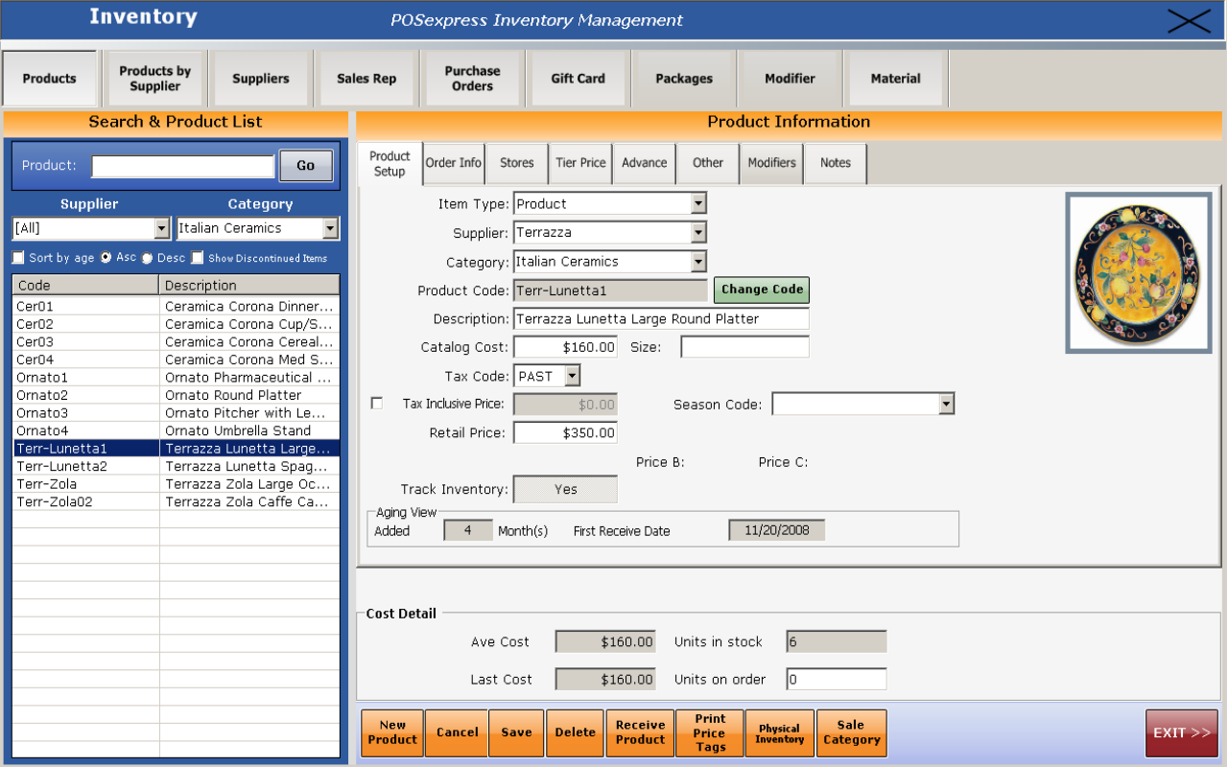

**Figure 2.1 Interface for Pos Prophet System**

* **Bronze Inventory POS System**

This is a complete inventory management system performs a Point of Sale function and multi warehouse stock control. System has receiving and shipping functions generates invoices, sale receipt. Export and import functions. More than 200 reports. Product labels with barcode, transfer order between locations, customers and vendors balances. Posibility to create planning transactions and to clone invoices.

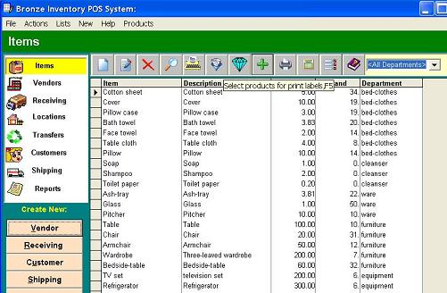

**Figure 2.2: Interface for Bronze Pos System**

* **Pos System**

POS System would definitely be a top choice for inventory control purpose. This system or manage the business inventory and warehouse in different branches as well. This system works as to the item list, reorder alert and print transaction slip. For the item list, POS System will display a list of the inventory system. We are allowed to search our inventory list manually or just conveniently using the filters available to search for faster result. Next, the reorder alert is a freely set the reorder alerts in inventory system. In the POS terminal, if the items has reached its reorder amount, the POS System will promp a message to remind to reorder that item. Lastly, using POS System, we can print out the slip of the adjustment or receive of our inventory including the reason of the transaction made. Deploying this function will allow to print out the adjustment slip or receive slip and let the supplier sign for record purposes.

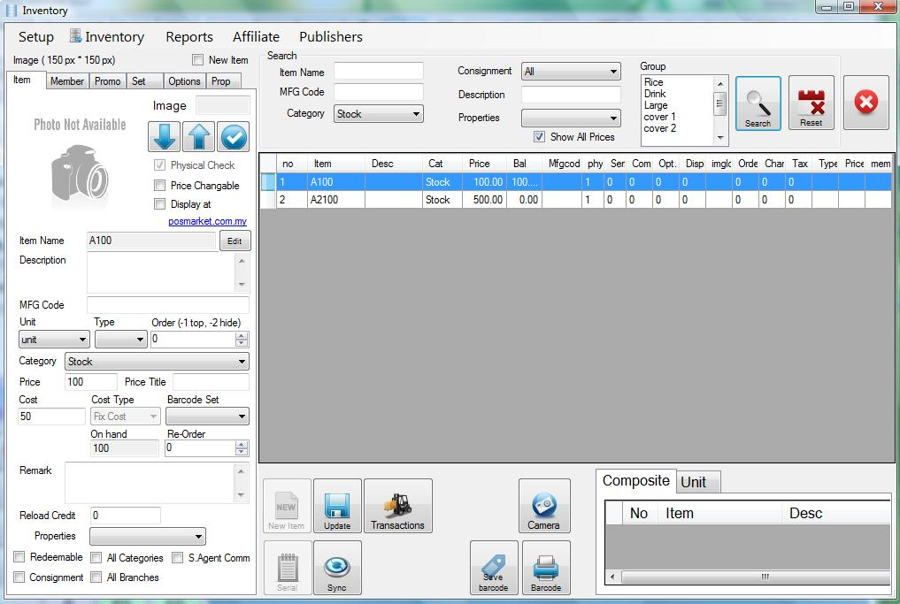

**Figure 2.3: Interface for Pos System**

Differences between existing system

|  |  |  |  |
| --- | --- | --- | --- |
| System name | Save Time | Attractive background | Stand alone |
| Kitabena Inventory System |  |  |  |
| Pos Prophet System |  |  |  |
| POS Bronze System |  |  |  |
| POS System |  |  |  |

**Figure 2.4 Comparison Table**

**2.2 Software Development**

Software is a collection of computer and related data that provides the instructions for telling a computer what to do it. Software refers to one or more computer program and data held in the storage of computer for some reasons. In other words, software is a set of programs, procedures, algorithm and its documentation concerned with the operation of data processing system. Program software performs the function of the program it implements, either by directly providing instruction to the computer hardware of serving as input to another piece of software.

**2.2.1 Xampp Server**



**Figure 2.5** Xampp Server Icon

**XAMPP** is a Windows web development environment. It allows to create web applications with Apache , PHP and a MySQL database. It also comes with PHP , MyAdmins to easily manage the database. Xampp installs automatically and its usage is very intuitive. You will be able to tune your server without touching the setting files, Once Xampp server install , you have the possibility to add as many Apache, MySQL ,and PHP release as you want.

**2.2.2. phpMyAdmin**



**Figure 2.6** phpMyAdmin Icon

**phpMyAdmin** is a free and open source written in PHP intended to handle the administration of MySQL with the use of a web browser. It can perform various task such as creating , modifying or deleting databases, tables , fields or rows , executing SQL statements or managing users and permissions . We use this software for our system is to save all data in database. phpMyAdmin in your Cpanel has a tool that allow you to optimize tables. Running this command will in essence defragment the table. Generally you don’t need to use it unless you have a tables this is often inserted, updated and deleted.

**2.2.3 Adobe Dreamweaver**



**Figure 2.7** Adobe Dreamweaver Icon

Adobe Dreamweaver software empoyers designers and developers to build standard based with confidence. Design visually or directly in code , develop pages with content management system and accurately test browser. It can use third-party “ Extension” to extends core functionality of the application, which any developer can write (largely in HTML and JavaScript) . Using Dreamweaver , web developers can edit and save reusable blocks of code in the snippets panel and retrieve them as need.

**CHAPTER 3**

**METHODOLOGY**

**3.1 Methodology**

A system of broad principles or rules from which specific methods or procedures may be derived to interpret or solve different problems within the scope particular dicipline. Unlike an algorithm, a methodology is not a formula but a set of practices.

Methodology is the systematic, theoretical analysis of method applied to a field of study. It comprises the theoretical analysis of the body of methods and principles associated with a branch of knowledge. Typically, it encompasses concepts such as paradigm, theoretical model, phases and quantitive or qualitative techniques.

For methodology, we will use ADDIE model for develop this project. The methodology is a set of practices that use technique and tools to archieve predetermined objectives. In methodology, have many stage and it will divided. Every phase will describe the activities in every stage for develop this project.

The ADDIE model is a framework that list generic processes that instructional designers and training developers use. It represents a guideline for building effective training and performance support tools in five phases.

**3.2 Prototype Methodology**

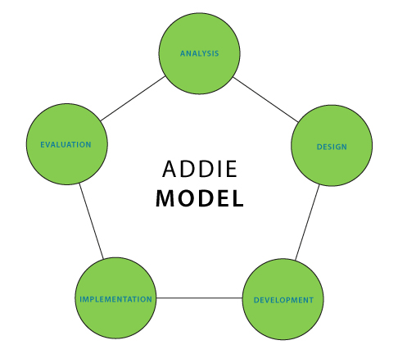

**Figure 3.1 Prototype Methodology**

1. Analyze

* A systematic exploration of the way things are the way things should be. The difference is the performance gap. The manual system is investigated amd improvement are identified based on information.

1. Design

* If the analysis identifies a performance gap, the Design phase will outline the performane objectives. The database and interface will be designed on requirement needed by this system.

1. Develop

* Using the information gathered in the Analyze and Design phase, the performance solution is created.

1. Implement

* This stage includes delivery of the performance solution. Database and interface design from design phase will be developed. Then, the coding will processed by writing.

1. Evaluate

* Measurement of how well the performance solution achieved the objectives.

**CHAPTER 4**

**Analysis & Design**

**4.1 Introduction of Analysis**

The introduction of this design phase report identifies the design problem. The objectives of the design, the assumption for design, the design alternatives and the selection of the design being reported. Also included for transition is a mapping of the entire report. Note that in longer reports, the selection of design is often a seperate section.

Moreover, all the processes that involved in the development of project will be documented and the design project development also will be explains. The main aspect to be highlighted in this section is an analysis of software, design and system interface design. This explain design Kitabena Inventory System in detail.

**4.2 FACT FINDING TECHNIQUE**

Fact-finding techniques is the specific methods analysis use for collecting data about requirement also called information gathering or data collection. The best analysis using variety of techniques and make sure the application and the needs for the new application are well understood before moving into design. There are 6 fact-finding techniques:

* Interview
* Questionnaire
* Documentation Review
* Observation
* Sampling
* Research

Based on fact-finding, our group choose interview before we go to the next methodology (design). From this interview, we get more details and information about Kitabena Inventory System.

* Interview
* Through a series of questions and answer, we planned meeting with one of owner company to get more information about the inventory system.
* Name of the interviewee: Mr. Abdul Rafik bin Yusof
* Total of involved in our project is the only the boss.
* Place of an area to interview, Temerloh, Pahang.

|  |  |  |
| --- | --- | --- |
| Date: | 18 February 2015 | |
| Time: | 1:15pm | |
| Place: | Perniagaan Kitabena Temerloh, Pahang | |
| Interviewee: | Mr.Abdul Rafik bin Yusof (Owner) | |
| Interviewer: | Nur Asyifa Binti Dollah Omar | |
| Objective: | 1. To convert a manual system to an inventory system. 2. To help manage the inventory system for the company. 3. To facilitate the process of record, update and delete of the data. | |
| Time | Questions | Answer |
| 2 Minutes | Can you tell me anything about the background of the company? | Firstly, the company start to sell out the items on 1990 with my partners which is my brothers but I’m starting to organize on the beginning of the year 2010.This company addressing at Lot 1378 Kampung Gau Baru km13,Jalan Maran, 28000 Temerloh, Pahang, Darul Makmur. This company just consist 10 of the employee here. Then, the company also supplying the steel products and constructing products. Furthermore, the company offer the painting services, wiring and plumbing building. |
| 2 Minutes | What the types of the products you are buying from the another company and how many quantity of that product? | We are just buying the steel products but with a large of quantity. With the large of the quantity we buy, we do not have a systematic record of the purchase to store the data.. |
| 2 Minutes | How the data of the supplier stored? | .The data it just stored in a lot of file. |
| 2 Minutes | Are you interested if we are offer the management system which is use the barcode scanner to rise up the company level? | We are so interested and strongly agree with the system to develop or using the system as a reference of the company products. |
| 2 Minutes | In your opinion, what are advantages of this company with the system? | The common thing as usual can save the time of the employee to store the data and it will be more efficient and systematic in a manner of this company. |
| 2 Minutes | Can I know the disadvantages of the company if there is no system to develop? | If there is no system is used, there will be a lot of usage of the file and there is not enough space to store the files. |
| 2 Minutes | If the system is developed, what are the element desirable by the user to design the system? | We want the button as a user-friendly, simply to understand, accurate colours, not too bright but not too dim. |

**Figure 4.1 An Interview Session**

**4.3 Introduction of Design**

Design is the creation of a plan or convention for the construction of an object or a system and what links creativity and innovation. It shapes ideas to become practical and attractive propositions for users.

In this chapter all the processes , which involved in the development off project will be documented and the designed project development also will be explain. The database method and how the database and table had been designed also will be explains. This explains design supervision system in details.

**4.4 Graphical User Interface (GUI)**

The graphical user interface is presented (displayed) on the computer screen. It is the result of processed user input and usually the primary interface for human- machine interaction.

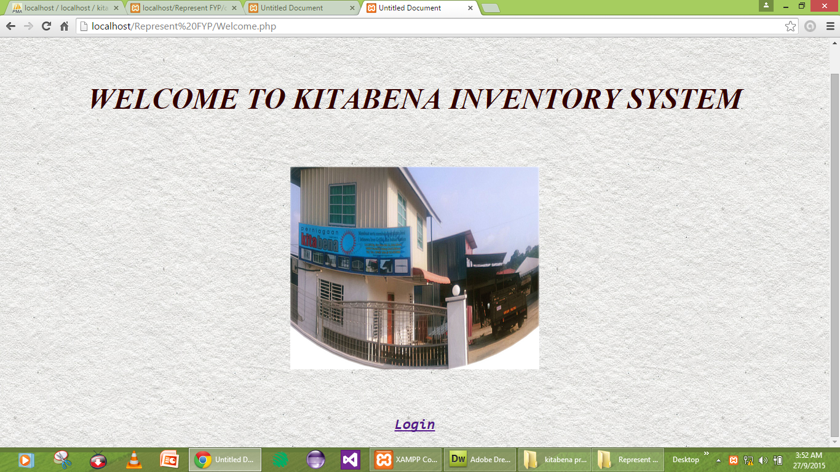

**Figure 4.2 Interface of Welcome Page**

In this page, user must click on the button Login to login the system.

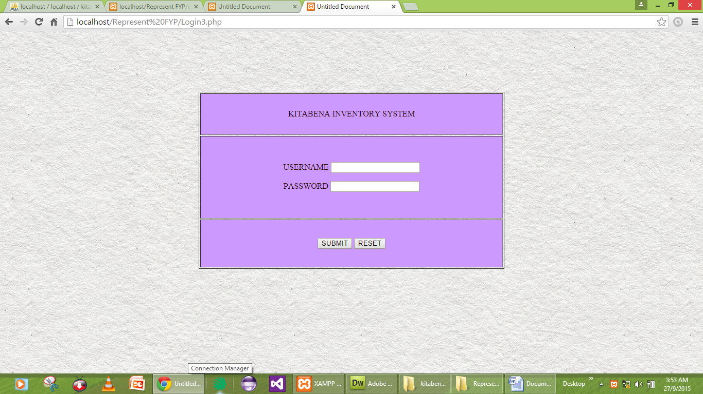

**Figure 4.3 Interface of Login Page**

In this page, user must insert username and password to login. Then, click Submit to confirm login. Click reset button to reset the username and password.

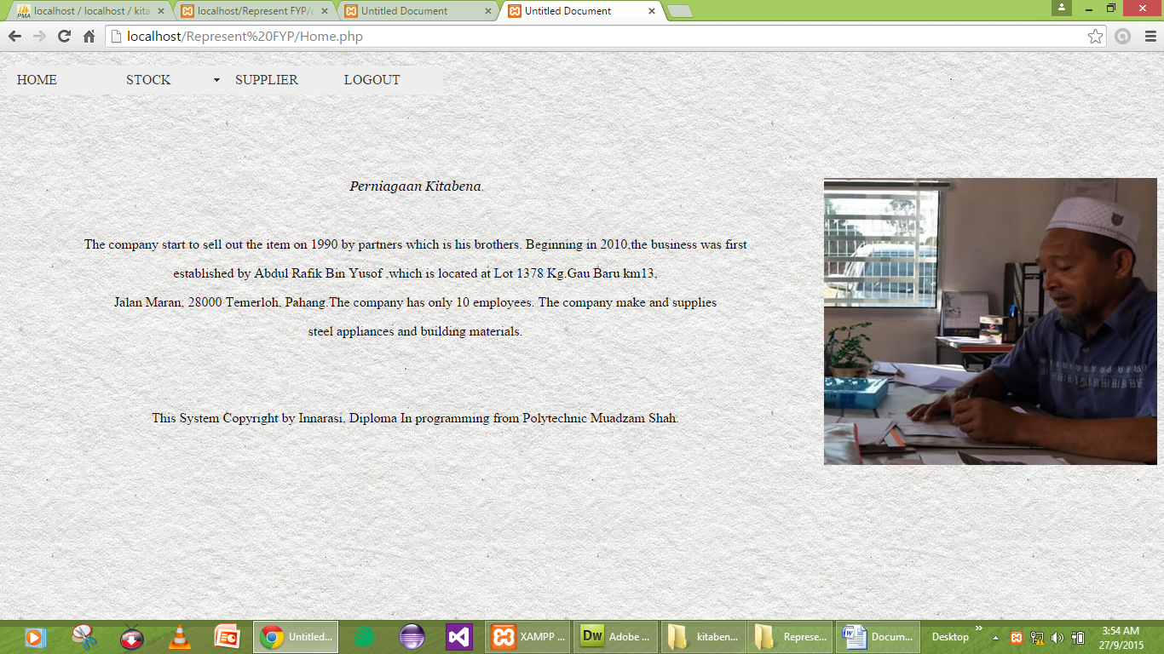

**Figure 4.4 Interface of Home Page**

In this page, its a little information about the company. On this page, user must click the sub menu button to make a choice to go to the another page.

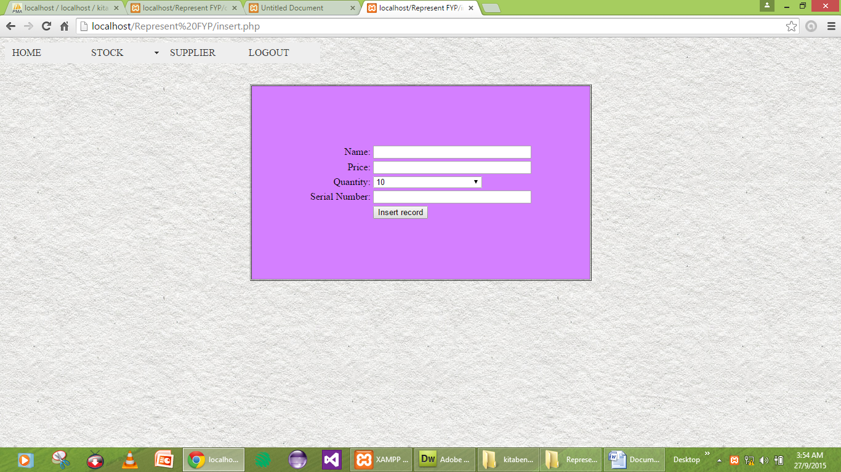

**Figure 4.5 Interface of Insert Page**

This page is function to insert the data on the database. User need to input the data first before click the insert record button.

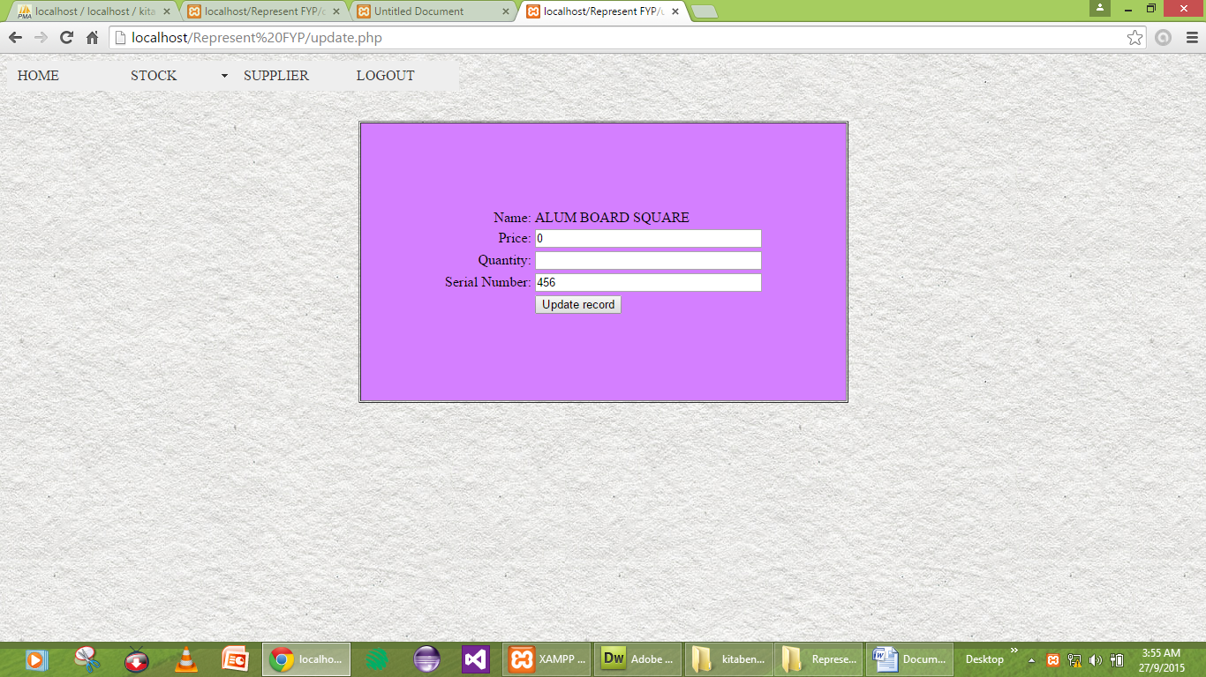

**Figure 4.6 Interface of Update Page**

On this page, user can update the data that have insert into the database. User need to insert the data first before click the update record button to change the database.

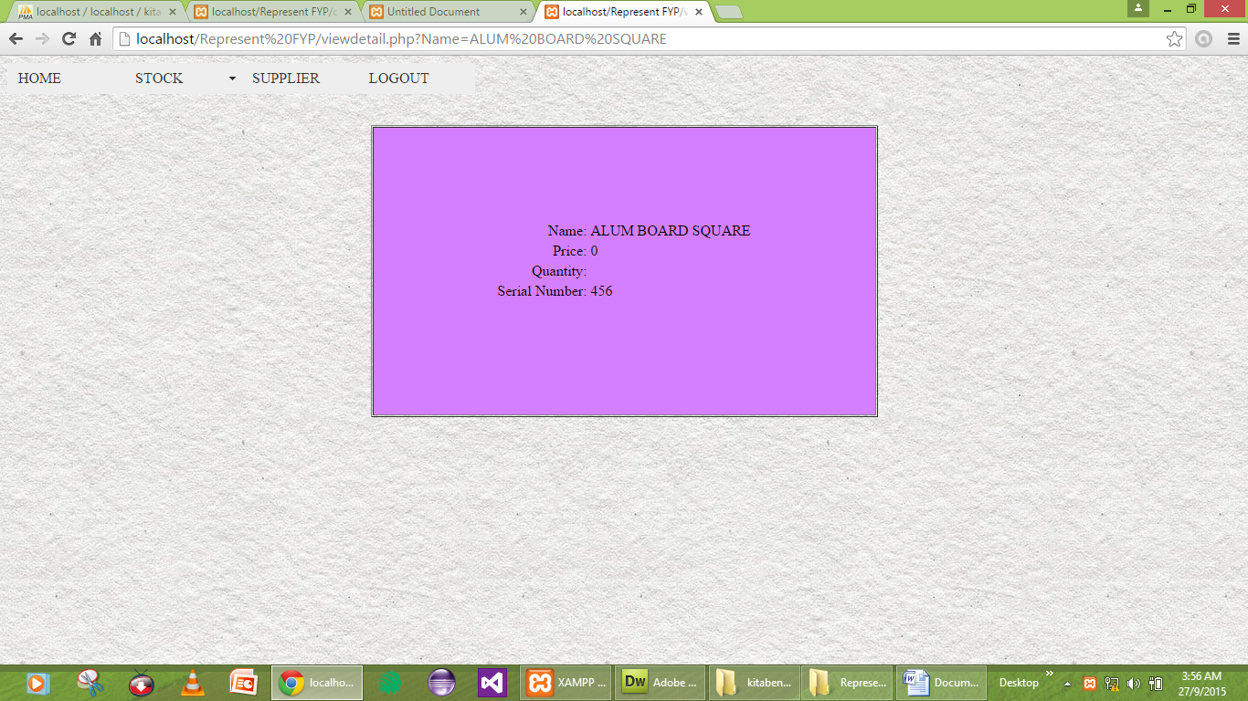

**Figure 4.7 Interface of View Detail Page**

This page function is to view the detail about the data that user had insert or update before this.

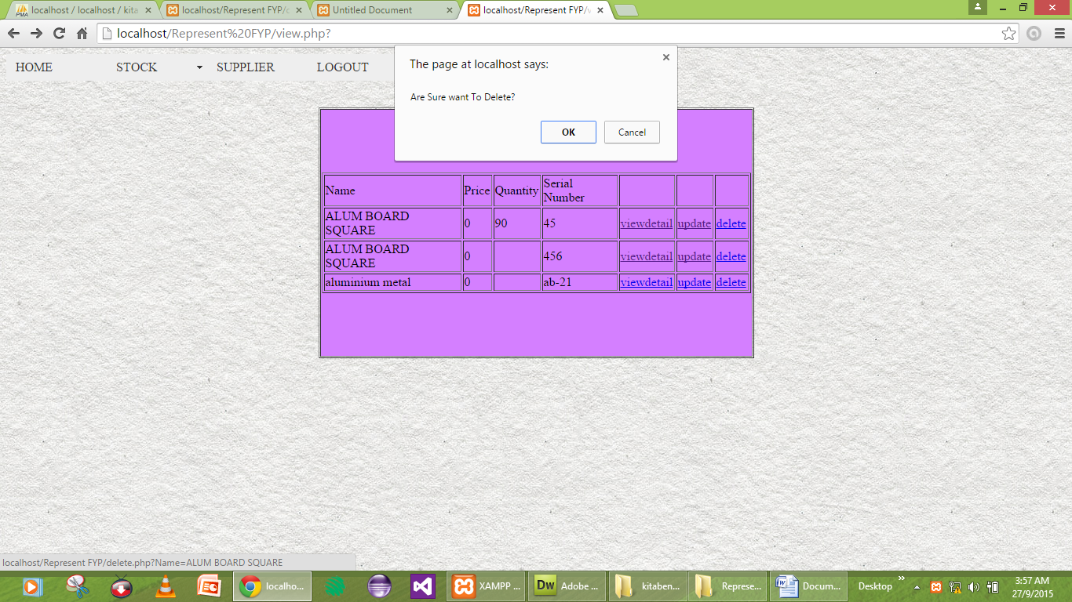 **Figure 4.8 Interface of Delete Page**

User can delete the information that has stored in the system by click the delete button. The pop up notification will appear to make a confirmation delete.

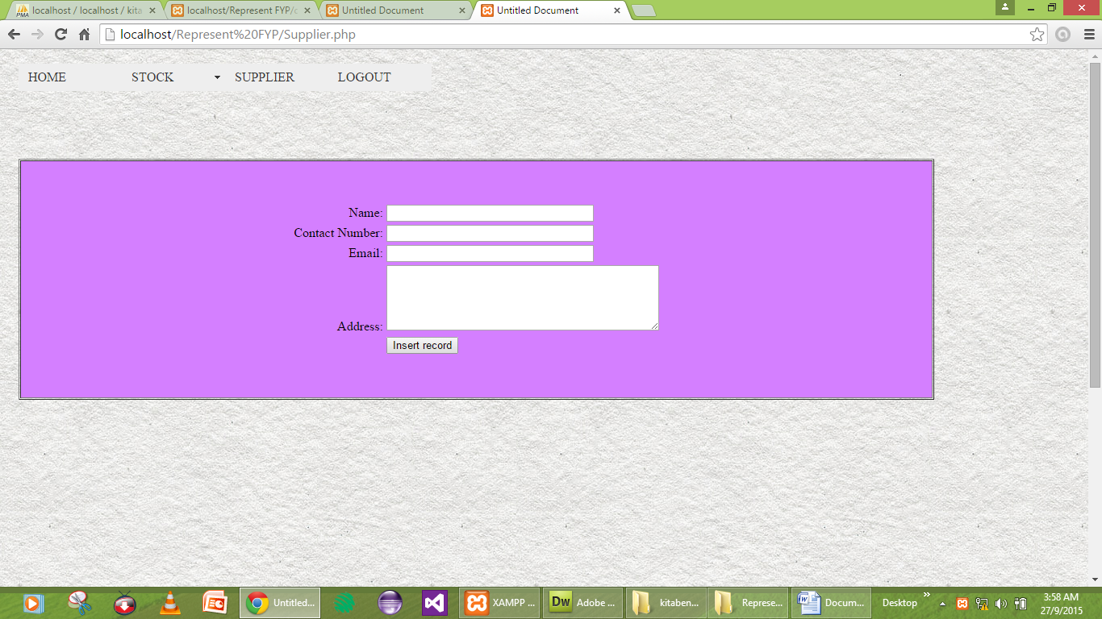

**Figure 4.9 Interface of Supplier Page**

User need to fill in the blank first to record the supplier details before click on the Submit button.

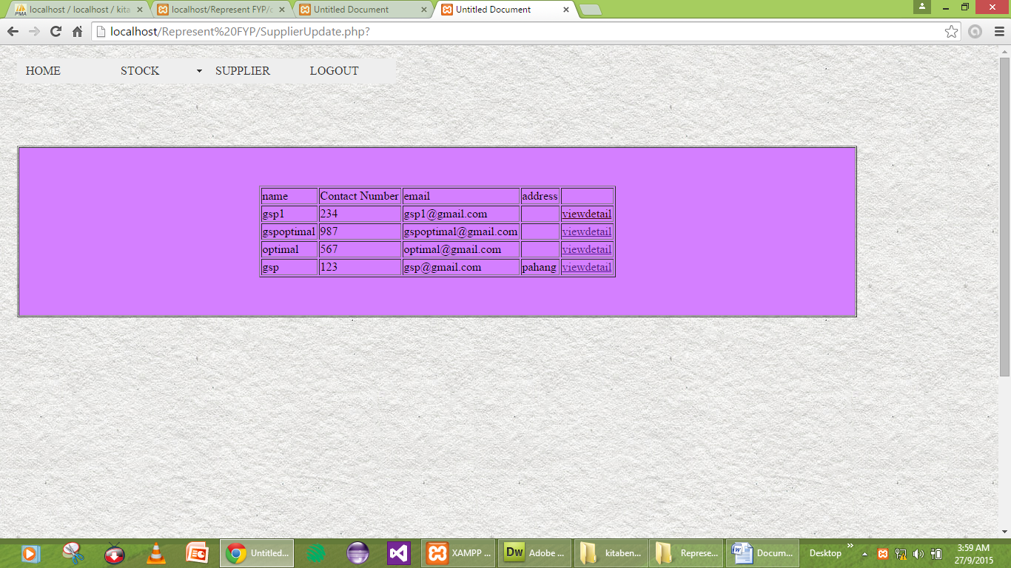

**Figure 4.10 Interface of Supplier Update**

User can update the supplier details on this page and click the view details to view the supplier details.

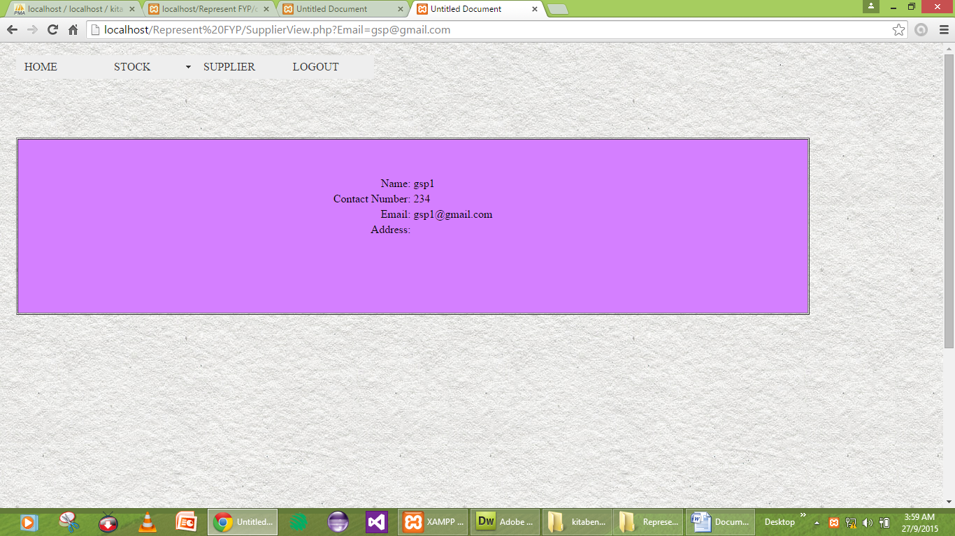

**Figure 4.11 Interface of Supplier Details**

The information about the supplier details will appear when the data is succeffull insert.

**4.5 Flowchart of the system**

A flowchart is a type of diagram that represents an algorithm or process , showing the steps as boxes of various kinds , and their order by connecting them with arrows. This diagrammatic representation illustrates a solution to given problem.

Welcome page

login

Enter Username,password

T F

Valid?

Home

insert

Case2

stock

Case11

Case3

view

delete

T

update

supplier

Case4

update

logout

**Figure 4.12 Flowchart**

Serial_Number,Quantity,price,name

Insert

T

view

viewdetail

F

delete

update

**Figure 4.13 Flowchart for Stock**

Name,Email,Address,Contact_Number

Submit

Result

**Figure 4.14 Flowchart for Supplier**

**4.6 Entity Relationship Diagram (ERD)**

Entity relationship diagram is a data modelling technique that creates a graphical representation of the entities, and the relationships between entities , within an information system.

|  |
| --- |
|  |

**Figure 4.15 Entity Relationship Diagram**

**CHAPTER 5**

**DEVELOPMENT AND TESTING**

**5.1 Introduction**

In this chapter , all the data trained and the results that had been acquired will be discussed and explain . Before development the project, collect data about bookstore process at the owner of bookstore. After completion the Bookstore Inventory System , all the require input are tested to ensure that it give the right result.

**5.2 SQL Database Developing Instructions**

Database is design after all required data and flow of Entity-Relationship Diagram (ERD) is identified. Database is the main thing that needs to be built before the system is developed. It is because a database will be used to stored all the related data and information that needed by system. A database can be reached and manipulated by using phpMyAdmin.

|  |
| --- |
| CREATE DATABASE KitabenaProject |

**Figure 5.1:SQL Query for create database KitabenaProject**

|  |
| --- |
| Create table kitabena(  login varchar  stock varchar  fail varchar  success varchar  supplier varchar,  ); |

**Figure 5.2: SQL Query for create table kitabena**

**5.3 User Interface Design**

The designated admin interface is developed by using the HTML and PHP source code. The purpose of it interface is design to make the user’s interaction as simple and effecient as possible, in terms of accomplishing user goals. Good user interface design facilities finishing the task at hand without drawing unnecessary attention to do it.

The diagram below shows the coding instruction for view data inventory function in HTML and PHP format.

**5.31 Welcome Page**



**Figure 5.3: Welcome Page**

|  |
| --- |
| <!DOCTYPE html PUBLIC "-//W3C//DTD XHTML 1.0 Transitional//EN" "http://www.w3.org/TR/xhtml1/DTD/xhtml1-transitional.dtd">  <html xmlns="http://www.w3.org/1999/xhtml">  <head>  <meta http-equiv="Content-Type" content="text/html; charset=utf-8" />  <title>Untitled Document</title>  <style type="text/css">  <!--  .WELCOME {  color: #0000A0;  }  body,td,th {  color: #0FF;  font-size: 24px;  font-family: Times New Roman, Times, serif;  font-style: italic;  }  body {  background-color: #FFF;  background-image: url(../images%20(6)  .jpg);  background-repeat: repeat;  color: #F00;  background-image: url(003-subtle-light-pattern-background-texture-vol51.jpg);  font-size: 24px;  }  .WELCOME .WELCOME strong {  color: #003;  }  .WELCOME h1 {  color: #303;  }  .WELCOME h2 kbd samp a strong {  color: #500;  }  .WELCOME h1 strong {  color: #300;  }  .WELCOME p kbd samp a strong {  font-size: 36px;  }  .WELCOME p kbd samp a strong {  font-size: 32px;  }  .WELCOME p kbd samp a strong {  font-size: 24px;  }  -->  </style>  <script type="text/javascript">  <!--  function MM_preloadImages() { //v3.0  var d=document; if(d.images){ if(!d.MM_p) d.MM_p=new Array();  var i,j=d.MM_p.length,a=MM_preloadImages.arguments; for(i=0; i<a.length; i++)  if (a[i].indexOf("#")!=0){ d.MM_p[j]=new Image; d.MM_p[j++].src=a[i];}}  }  function MM_findObj(n, d) { //v4.01  var p,i,x; if(!d) d=document; if((p=n.indexOf("?"))>0&&parent.frames.length) {  d=parent.frames[n.substring(p+1)].document; n=n.substring(0,p);}  if(!(x=d[n])&&d.all) x=d.all[n]; for (i=0;!x&&i<d.forms.length;i++) x=d.forms[i][n];  for(i=0;!x&&d.layers&&i<d.layers.length;i++) x=MM_findObj(n,d.layers[i].document);  if(!x && d.getElementById) x=d.getElementById(n); return x;  }  function MM_nbGroup(event, grpName) { //v6.0  var i,img,nbArr,args=MM_nbGroup.arguments;  if (event == "init" && args.length > 2) {  if ((img = MM_findObj(args[2])) != null && !img.MM_init) {  img.MM_init = true; img.MM_up = args[3]; img.MM_dn = img.src;  if ((nbArr = document[grpName]) == null) nbArr = document[grpName] = new Array();  nbArr[nbArr.length] = img;  for (i=4; i < args.length-1; i+=2) if ((img = MM_findObj(args[i])) != null) {  if (!img.MM_up) img.MM_up = img.src;  img.src = img.MM_dn = args[i+1];  nbArr[nbArr.length] = img;  } }  } else if (event == "over") {  document.MM_nbOver = nbArr = new Array();  for (i=1; i < args.length-1; i+=3) if ((img = MM_findObj(args[i])) != null) {  if (!img.MM_up) img.MM_up = img.src;  img.src = (img.MM_dn && args[i+2]) ? args[i+2] : ((args[i+1])? args[i+1] : img.MM_up);  nbArr[nbArr.length] = img;  }  } else if (event == "out" ) {  for (i=0; i < document.MM_nbOver.length; i++) {  img = document.MM_nbOver[i]; img.src = (img.MM_dn) ? img.MM_dn : img.MM_up; }  } else if (event == "down") {  nbArr = document[grpName];  if (nbArr)  for (i=0; i < nbArr.length; i++) { img=nbArr[i]; img.src = img.MM_up; img.MM_dn = 0; }  document[grpName] = nbArr = new Array();  for (i=2; i < args.length-1; i+=2) if ((img = MM_findObj(args[i])) != null) {  if (!img.MM_up) img.MM_up = img.src;  img.src = img.MM_dn = (args[i+1])? args[i+1] : img.MM_up;  nbArr[nbArr.length] = img;  } }  }  //-->  </script>  </head>  <body onload="MM_preloadImages('untitled.jpg','IMG-20150122-WA0000.jpg')">  <div align="center" class="WELCOME">  <h1>&nbsp;</h1>  <h1><strong>WELCOME TO KITABENA INVENTORY SYSTEM</strong> </h1>  <p>&nbsp;</p>  <p><a href="javascript:;" target="_top" onclick="MM_nbGroup('down','group1','IMG6219','untitled.jpg',1)" onmouseover="MM_nbGroup('over','IMG6219','IMG-20150122-WA0000.jpg','',1)" onmouseout="MM_nbGroup('out')"><img src="IMG_6219.jpg" alt="" name="IMG6219" width="405" height="330" border="0" align="texttop" id="IMG6219" onload="" /></a> </p>  <p>&nbsp;</p>  <p><kbd><samp><a href="Login3.php" target="_top"><strong>Login</strong></a></samp></kbd><a href="Login3.php"><strong></strong></a></p>  </div>  <center>  </body>  </html> |

**Figure 5.4 : Code of Welcome Page**

**5.3.2 Login Page**



**Figure 5.5: Login Page**

|  |
| --- |
| <form ACTION="<?php echo $loginFormAction; ?>" id="form1" name="form1" enctype="multipart/form-data" method="POST">  <p>&nbsp;</p>  <p>&nbsp;</p>  <table width="594" height="345" border="1" align="center">  <tr>  <td height="77" bgcolor="#CC99FF"><div align="center">KITABENA INVENTORY SYSTEM </div></td>  </tr>  <tr>  <td bgcolor="#CC99FF"><p align="center">USERNAME  <label for="textfield"></label>  <input name="textfield" type="text" id="textfield" size="20" maxlength="20" />  </p>  <p align="center">PASSWORD  <label for="textfield2"></label>  <input name="textfield2" type="password" id="textfield2" size="20" maxlength="20" />  </p></td>  </tr>  <tr>  <td bgcolor="#CC99FF"><div align="center">    <label for="Submit"></label>  <input type="submit" name="Submit" id="Submit" value="SUBMIT" />  <input type="reset" name="RESET" id="RESET" value="RESET" />  </div></td>  </tr>  </table>  .  <p>.</p>  <p>.</p>  <p>.</p>  <p>  <label for="SUBMIT"></label>  <label for="RESET"></label>  </p>  </form>  </body>  </html> |

**Figure 5.6: Code of Login Page**

**5.3.3 Home Page**



**Figure 5.7: Home Page**

|  |
| --- |
| <div align="justify"> </div>  <p align="justify">&nbsp;</p>  <div align="left">  <p>&nbsp;</p>  <p><a name="_GoBack" id="_GoBack"></a></p>  <table width="12" border="0" align="right" cellpadding="0" cellspacing="0">  <tr>  <td><img src="untitled.jpg" alt="&lt;img src=&quot;../untitled.jpg&quot; width=&quot;786&quot; height=&quot;444&quot; /&gt;" width="391" height="337" /></td>  </tr>  </table>  </div>  <p align="left"><em>Perniagaan Kitabena </em></p>  <p>&nbsp;</p>  <p>The company start to sell out the item on 1990 by partners which is his brothers. Beginning in 2010,the business was first</p>  <p> established by Abdul Rafik Bin Yusof ,which is located at Lot 1378 Kg.Gau Baru km13, </p>  <p>Jalan Maran, 28000 Temerloh, Pahang.The company has only 10 employees. The company make and supplies </p>  <p>steel appliances and building materials.</p>  <p>&nbsp;</p>  <p>&nbsp;</p>  <p>This System Copyright by Innarasi, Diploma In programming from Polytechnic Muadzam Shah.</p>  <p align="left">&nbsp;</p>  </form>  <p></form>  </p>  <script type="text/javascript">  <!--  var MenuBar1 = new Spry.Widget.MenuBar("MenuBar1", {imgDown:"SpryAssets/SpryMenuBarDownHover.gif", imgRight:"SpryAssets/SpryMenuBarRightHover.gif"});  //-->  </script> |

**Figure 5.8: Code of Home Page**

**5.3.4 Insert Page**



**Figure 5.9: Insert Page**

|  |
| --- |
| <table width="555" height="320" border="1" cellpadding="1" cellspacing="1">  <tr bgcolor="#D4BF55">  <td width="372" bgcolor="#D47FFF"><div align="center">  <table align="center">  <tr valign="baseline">  <td nowrap="nowrap" align="right">Name:</td>  <td><input type="text" name="Name" value="" size="32" /></td>  </tr>  <tr valign="baseline">  <td nowrap="nowrap" align="right">Price:</td>  <td><input type="text" name="Price" value="" size="32" /></td>  </tr>  <tr valign="baseline">  <td nowrap="nowrap" align="right">Quantity:</td>  <td><label for="select"></label>  <select name="select" id="select">  <option value="">10</option>  <option value="">20</option>  <option value="">30</option>  <option value="">40</option>  <option value="">50</option>  <option value="">60</option>  <option value="">70</option>  <option value="">80</option>  <option value="">90</option>  <option value="">100</option>  <?php  do {  ?>  <option value="<?php echo $row_Stock['Name']?>"><?php echo $row_Stock['Name']?></option>  <?php  } while ($row_Stock = mysql_fetch_assoc($Stock));  $rows = mysql_num_rows($Stock);  if($rows > 0) {  mysql_data_seek($Stock, 0);  $row_Stock = mysql_fetch_assoc($Stock);  }  ?>  </select></td>  </tr>  <tr valign="baseline">  <td nowrap="nowrap" align="right">Serial Number:</td>  <td><input type="text" name="Serial_Number" value="" size="32" /></td>  </tr>  <tr valign="baseline">  <td nowrap="nowrap" align="right">&nbsp;</td>  <td><input type="submit" value="Insert record" /></td>  </tr>  </table> |

**Figure 5.10: Code of Insert Page**

**5.3.5 Update Page**



**Figure 5.11: Update Page**

|  |
| --- |
| <table align="center">  <tr valign="baseline">  <td nowrap="nowrap" align="right">Name:</td>  <td><?php echo $row_Stock['Name']; ?></td>  </tr>  <tr valign="baseline">  <td nowrap="nowrap" align="right">Price:</td>  <td><input type="text" name="Price" value="<?php echo htmlentities($row_Stock['Price'], ENT_COMPAT, ''); ?>" size="32" /></td>  </tr>  <tr valign="baseline">  <td nowrap="nowrap" align="right">Quantity:</td>  <td><input type="text" name="Quantity" value="<?php echo htmlentities($row_Stock['Quantity'], ENT_COMPAT, ''); ?>" size="32" /></td>  </tr>  <tr valign="baseline">  <td nowrap="nowrap" align="right">Serial Number:</td>  <td><input type="text" name="Serial_Number" value="<?php echo htmlentities($row_Stock['Serial Number'], ENT_COMPAT, ''); ?>" size="32" /></td>  </tr>  <tr valign="baseline">  <td nowrap="nowrap" align="right">&nbsp;</td>  <td><input type="submit" value="Update record" /></td>  </tr>  </table>  <input type="hidden" name="Name" value="<?php echo $row_Stock['Name']; ?>" />  <input type="hidden" name="MM_update" value="form4" /></td>  </tr>  </table> |

**Figure 5.12: Code of Update Page**

**5.3.6 View Detail Page**



**Figure 5.13: View Detail Page**

|  |
| --- |
| <table align="center">  <tr valign="baseline">  <td nowrap="nowrap" align="right">Name:</td>  <td><?php echo $row_Stock['Name']; ?></td>  </tr>  <tr valign="baseline">  <td nowrap="nowrap" align="right">Price:</td>  <td><?php echo $row_Stock['Price']; ?></td>  </tr>  <tr valign="baseline">  <td nowrap="nowrap" align="right">Quantity:</td>  <td><?php echo $row_Stock['Quantity']; ?></td>  </tr>  <tr valign="baseline">  <td nowrap="nowrap" align="right">Serial Number:</td>  <td><?php echo $row_Stock['Serial Number']; ?></td>  </tr>  <tr valign="baseline">  <td nowrap="nowrap" align="right">&nbsp;</td>  <td>&nbsp;</td>  </tr>  </table></td>  </tr>  </table> |

**Figure 5.14: Code of View Detail Page**

**5.3.7 Delete Page**



**Figure 5.15: Delete Data Page**

|  |
| --- |
| if (!function_exists("GetSQLValueString")) {  function GetSQLValueString($theValue, $theType, $theDefinedValue = "", $theNotDefinedValue = "")  {  if (PHP_VERSION < 6) {  $theValue = get_magic_quotes_gpc() ? stripslashes($theValue) : $theValue;  }  $theValue = function_exists("mysql_real_escape_string") ? mysql_real_escape_string($theValue) : mysql_escape_string($theValue);  switch ($theType) {  case "text":  $theValue = ($theValue != "") ? "'" . $theValue . "'" : "NULL";  break;  case "long":  case "int":  $theValue = ($theValue != "") ? intval($theValue) : "NULL";  break;  case "double":  $theValue = ($theValue != "") ? doubleval($theValue) : "NULL";  break;  case "date":  $theValue = ($theValue != "") ? "'" . $theValue . "'" : "NULL";  break;  case "defined":  $theValue = ($theValue != "") ? $theDefinedValue : $theNotDefinedValue;  break;  }  return $theValue;  }  }  $editFormAction = $_SERVER['PHP_SELF'];  if (isset($_SERVER['QUERY_STRING'])) {  $editFormAction .= "?" . htmlentities($_SERVER['QUERY_STRING']);  }  if ((isset($_POST["MM_insert"])) && ($_POST["MM_insert"] == "form4")) {  $insertSQL = sprintf("INSERT INTO stock (Name, Price, Quantity, `Serial Number`) VALUES (%s, %s, %s, %s)",  GetSQLValueString($_POST['Name'], "text"),  GetSQLValueString($_POST['Price'], "double"),  GetSQLValueString($_POST['Quantity'], "int"),  GetSQLValueString($_POST['Serial_Number'], "text"));  mysql_select_db($database_Kitabenaconnnection, $Kitabenaconnnection);  $Result1 = mysql_query($insertSQL, $Kitabenaconnnection) or die(mysql_error());  $insertGoTo = "view.php";  if (isset($_SERVER['QUERY_STRING'])) {  $insertGoTo .= (strpos($insertGoTo, '?')) ? "&" : "?";  $insertGoTo .= $_SERVER['QUERY_STRING'];  }  header(sprintf("Location: %s", $insertGoTo));  }  if ((isset($_POST["MM_update"])) && ($_POST["MM_update"] == "form4")) {  $updateSQL = sprintf("UPDATE stock SET Price=%s, Quantity=%s, `Serial Number`=%s WHERE Name=%s",  GetSQLValueString($_POST['Price'], "double"),  GetSQLValueString($_POST['Quantity'], "int"),  GetSQLValueString($_POST['Serial_Number'], "text"),  GetSQLValueString($_POST['Name'], "text"));  mysql_select_db($database_Kitabenaconnnection, $Kitabenaconnnection);  $Result1 = mysql_query($updateSQL, $Kitabenaconnnection) or die(mysql_error());  $updateGoTo = "view.php";  if (isset($_SERVER['QUERY_STRING'])) {  $updateGoTo .= (strpos($updateGoTo, '?')) ? "&" : "?";  $updateGoTo .= $_SERVER['QUERY_STRING'];  }  header(sprintf("Location: %s", $updateGoTo));  }  mysql_select_db($database_Kitabenaconnnection, $Kitabenaconnnection);  $query_Stock = "SELECT * FROM stock";  $Stock = mysql_query($query_Stock, $Kitabenaconnnection) or die(mysql_error());  $row_Stock = mysql_fetch_assoc($Stock);  $totalRows_Stock = mysql_num_rows($Stock);  ?> |

**Figure 5.16: Code of Delete Data Page**

**5.3.8 Supplier Page**



**Figure 5.17: Supplier Page**

|  |
| --- |
| <table width="1135" border="1" cellspacing="1" cellpadding="1">  <tr>  <td width="1127" bgcolor="#D47FFF"><p>&nbsp;</p>  <form action="<?php echo $editFormAction; ?>" method="post" enctype="multipart/form-data" name="form2" id="form2">  <table align="center">  <tr valign="baseline">  <td nowrap="nowrap" align="right">Name:</td>  <td><input type="text" name="name" value="" size="32" /></td>  </tr>  <tr valign="baseline">  <td nowrap="nowrap" align="right">Contact Number:</td>  <td><input type="text" name="Contact_Number" value="" size="32" /></td>  </tr>  <tr valign="baseline">  <td nowrap="nowrap" align="right">Email:</td>  <td><input type="text" name="email" value="" size="32" /></td>  </tr>  <tr valign="baseline">  <td nowrap="nowrap" align="right">Address:</td>  <td><label for="textarea"></label>  <textarea name="textarea" id="textarea" cols="45" rows="5"></textarea></td>  </tr>  <tr valign="baseline">  <td nowrap="nowrap" align="right">&nbsp;</td>  <td><input type="submit" value="Insert record" /></td>  </tr>  </table>  <input type="hidden" name="MM_insert" value="form2" />  </form>  <p>&nbsp;</p></td>  </tr>  </table>  <p>&nbsp;</p>  <p>&nbsp;</p>  <p>&nbsp;</p>  <p>&nbsp;</p>  <p>&nbsp;</p>  <p>&nbsp;</p>  <p>&nbsp;</p>  <p>&nbsp;</p>  <p>&nbsp;</p>  <p>&nbsp;</p>  <p>&nbsp;</p>  <p>&nbsp;</p>  <p>&nbsp;</p>  <p>&nbsp; </p></td>  </tr>  </table> |

**Figure 5.18: Code of Supplier Page**

**5.3.9 Update Details Supplier**



**Figure 5.19: Update Details Supplier**

|  |
| --- |
| <table width="1135" border="1" cellspacing="1" cellpadding="1">  <tr>  <td width="1127" bgcolor="#D47FFF"><p>&nbsp;</p>  <form method="post" enctype="multipart/form-data" name="form2" id="form2">  </form>  <div align="center">  <table border="1">  <tr>  <td>name</td>  <td>Contact Number</td>  <td>email</td>  <td>address</td>  <td>&nbsp;</td>  </tr>  <?php do { ?>  <tr>  <td><?php echo $row_Supplier['name']; ?></td>  <td><?php echo $row_Supplier['Contact Number']; ?></td>  <td><?php echo $row_Supplier['email']; ?></td>  <td><?php echo $row_Supplier['address']; ?></td>  <td><a href="SupplierView.php?Email=<?php echo $row_Supplier['email']; ?>">viewdetail</a></td>  </tr>  <?php } while ($row_Supplier = mysql_fetch_assoc($Supplier)); ?>  </table>  </div>  <p>&nbsp;</p></td>  </tr>  </table>  <p>&nbsp;</p>  <p>&nbsp;</p>  <p>&nbsp;</p>  <p>&nbsp;</p>  <p>&nbsp;</p>  <p>&nbsp;</p>  <p>&nbsp;</p>  <p>&nbsp;</p>  <p>&nbsp;</p>  <p>&nbsp;</p>  <p>&nbsp;</p>  <p>&nbsp;</p>  <p>&nbsp;</p>  <p>&nbsp; </p></td>  </tr>  </table> |

**Figure 5.20: Code of Update Details Supplier**

**5.3.10 View Details Supplier**



**Figure 5.21: View Details Supplier**

|  |
| --- |
| <table width="1135" border="1" cellspacing="1" cellpadding="1">  <tr>  <td width="1127" bgcolor="#D47FFF"><p>&nbsp;</p>  <form method="post" enctype="multipart/form-data" name="form2" id="form2">  </form>  <form action="<?php echo $editFormAction; ?>" method="post" name="form5" id="form5">  <table align="center">  <tr valign="baseline">  <td nowrap="nowrap" align="right">Name:</td>  <td><?php echo $row_Supplier['name']; ?></td>  </tr>  <tr valign="baseline">  <td nowrap="nowrap" align="right">Contact Number:</td>  <td><?php echo $row_Supplier['Contact Number']; ?></td>  </tr>  <tr valign="baseline">  <td nowrap="nowrap" align="right">Email:</td>  <td><?php echo $row_Supplier['email']; ?></td>  </tr>  <tr valign="baseline">  <td nowrap="nowrap" align="right">Address:</td>  <td><?php echo $row_Supplier['address']; ?></td>  </tr>  <tr valign="baseline">  <td nowrap="nowrap" align="right">&nbsp;</td>  <td>&nbsp;</td>  </tr>  </table>  <input type="hidden" name="MM_update" value="form5" />  <input type="hidden" name="name" value="<?php echo $row_Supplier['name']; ?>" />  </form>  <p>&nbsp;</p>  <p>&nbsp;</p></td>  </tr>  </table>  <p>&nbsp;</p>  <p>&nbsp;</p>  <p>&nbsp;</p>  <p>&nbsp;</p>  <p>&nbsp;</p>  <p>&nbsp;</p>  <p>&nbsp;</p>  <p>&nbsp;</p>  <p>&nbsp;</p>  <p>&nbsp;</p>  <p>&nbsp;</p>  <p>&nbsp;</p>  <p>&nbsp;</p>  <p>&nbsp; </p></td>  </tr>  </table> |

**Figure 5.22: Code of View Details Supplier**

* 1. **Testing Phase**
     1. **Unit Test**

A unit test is performed on a self-contained unit (usually a class or method) and should be performed whenever a unit has been implemented or updating of a unit has been completed. This mean its run whenever you’ve written a class/method, fixed a bug, and changed functionality.

Testing is done in the development process while developer completes the unit development. The object of this testing is to check that as individual parts are functioning as expected. Basically Unit testing is typically carried out by the developer.

**5.4.1 (i) Login**

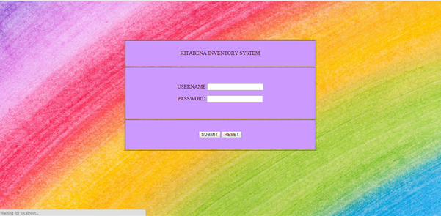

**Figure 5.23: Login User (codes refer Figure 5.6)**

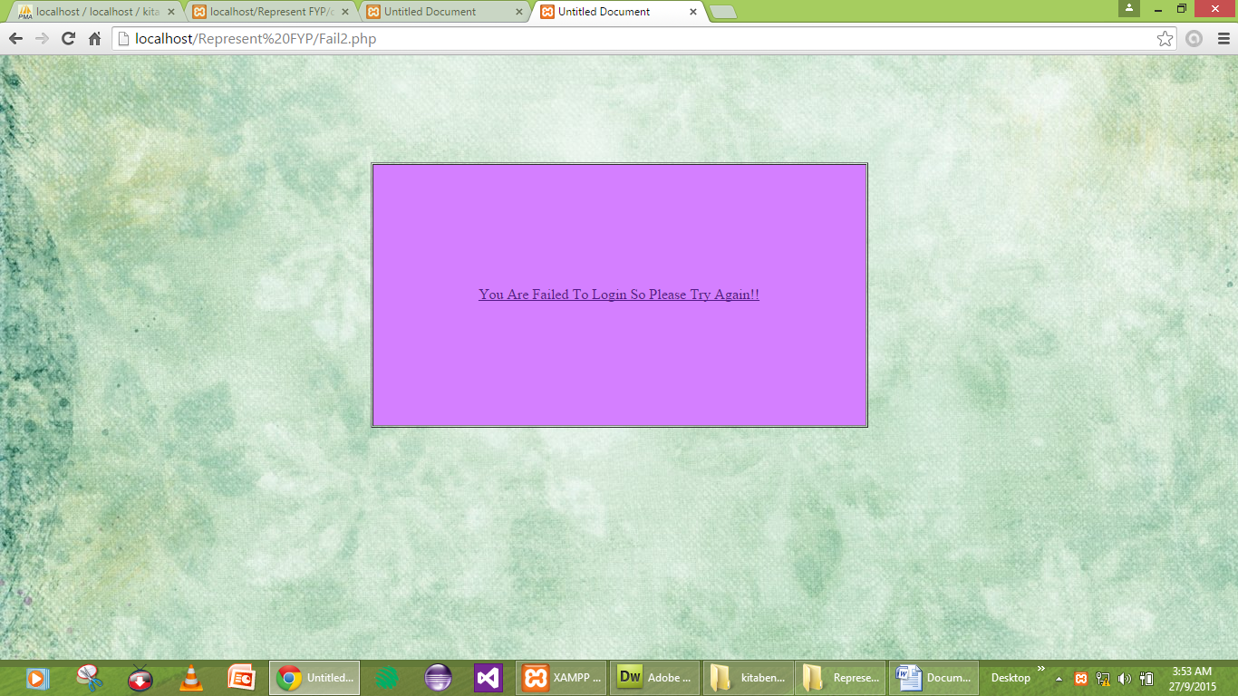

**Figure 5.24: Failed to Login**

|  |
| --- |
| <!DOCTYPE html PUBLIC "-//W3C//DTD XHTML 1.0 Transitional//EN" "http://www.w3.org/TR/xhtml1/DTD/xhtml1-transitional.dtd">  <html xmlns="http://www.w3.org/1999/xhtml">  <head>  <meta http-equiv="Content-Type" content="text/html; charset=utf-8" />  <title>Untitled Document</title>  <style type="text/css">  <!--  body,td,th {  font-family: Times New Roman, Times, serif;  font-size: 16px;  color: #FF9FAA;  }  body {  background-image:url(Inna/Background/765-0366_PI_1000350MN.jpg);  color: #0D0;  }  -->  </style></head>  <body>  <div align="center">  <p>&nbsp;</p>  <p>&nbsp;</p>  <p>&nbsp;</p>  </div>  <div align="center">  <table width="549" height="289" border="1" cellpadding="1" cellspacing="1">  <tr>  <td width="541" height="285" bgcolor="#FF9FFF"><div align="center"><a href="Login3.php">You Are Failed To Login So Please Try Again!!</a></div></td>  </tr>  </table>  </div>  </body>  </html> |

**Figure 5.25: Code of Failed Login**

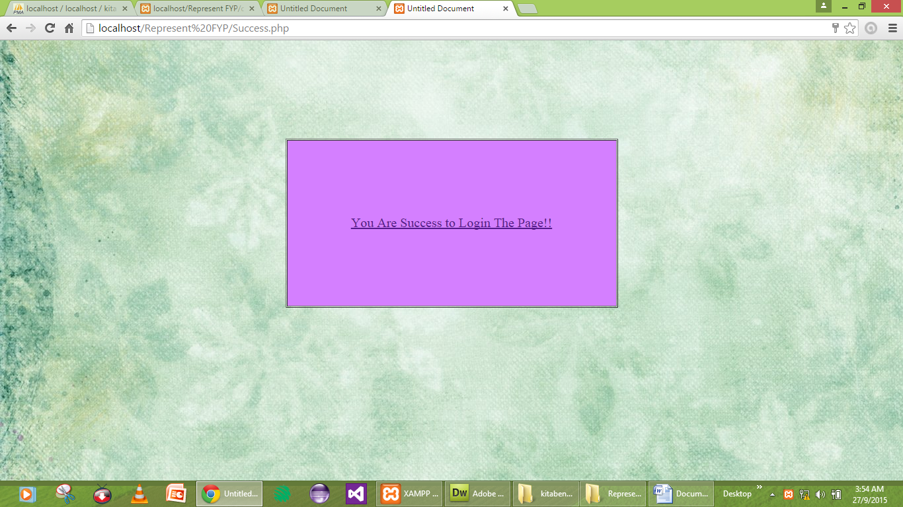

**Figure 5.26: Success Login**

|  |
| --- |
| <table width="503" height="256" border="1" align="center" cellpadding="1" cellspacing="1">  <tr>  <td width="495" bgcolor="#FF9FFF"><div align="center"><a href="Home.php"> You Are Success to Login The Page!!</a> <a href="Home.php"></a></div></td>  </tr>  </table> |

**Figure 5.27: Code Of Success Login**

**5.4.1 (ii) Insert Record**



**Figure 5.28: Insert Record (code refer Figure 5.9)**

**5.4.1 (iii) Update Record** 

**Figure 5.29: Update Record (code refer Figure 5.11)**

**5.4.1 (iv) Delete Record**

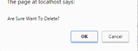

**Figure 5.30: Delete Notification**

|  |
| --- |
| <a href="delete.php?Serial_Number=<?php echo $row_Stock['Serial Number']; ?>"onClick="return confirm('Are Sure Want To Delete?')">delete</a> |

**Figure 5.31: Code Of Delete Notification**

* + 1. **Integration Testing**

System Integration Testing is started after the individual software module are integrated as a group. A typical software project consists of multiple modules and these are developed by a different developers. So in integration testing is focuses to check that after integrating modules is two modules are communicating with each other or not. It is critical to test every module’s effect on the entire program model. Most of the issue are observed in this type of testing.

* + 1. **(i) Button Menu and Sub Menu** 

**Figure 5.32: Button Menu and Sub Menu**

|  |
| --- |
| <li><a href="Home.php">HOME</a></li>  <li><a href="#" class="MenuBarItemSubmenu">STOCK</a>  <ul>  <li><a href="insert.php">INSERT</a></li>  <li><a href="update.php">UPDATE</a></li>  <li><a href="view.php">DELETE</a></li>  </ul>  </li>  <li><a href="Supplier.php">SUPPLIER</a></li>  <li><a href="Welcome.php">LOGOUT</a></li>  </ul>  </div> |

**Figure 5.33: Code Of Menu and Sub Menu**

* + 1. **System Testing**

In this phase it’s first time end to end testing application on the complete and fully integrated system before it’s been published. In this phase all units are integrated and done the system to check whether the all model or unit are integrated properly or not and the system as whole doing as mention as per the system requirement document that call this phase as the System Testing.



**Figure 5.34: Supplier registration form**

* 1. **Conclusion**

In this documentation, there are three phases in the testing phase which is Unit Testing, Integration Testing, and System Testing. This phase is used to record and keep track of the error occurred from the application development, from there it know the error in our application. We get the feedback from user in testing phase. In conclusion, after we make our testing of applications being developed, we have made our application testing prior to the supervisor. Testing phase is one of the important phases in the development of projects before to implementation phase.

**CHAPTER 6**

**SUGGESTION AND CONCLUSION**

**6.1 Suggestion**

Kitabena Inventory System is a first project system for first version. Although we have do some detail research, but we found some weakness for this project. Thus , we have make a few list of suggestion that maybe can be used to improve this system for future.

1. Upgrade and add more function
2. Improving the system.

**6.2 Conclusion**

Kitabena Inventory System is successful project for us. Although is hard to us for develop this system. We already achieved our objective for this project.

Kitabena Inventory System can helps the user to managing the proccessing of key in data for their material. Then, user can save time when store the data.

**REFERENCES**

*Abdul Rafik bin Yusof.*(2014 December 28).Personal Interview.

*POS Prophet System.* Retrieved 10th January 2015, from <http://pointofsale.com/Retail-point-of-sale-software-multi-store/pos-prophet-systems.html>

*Bronze Pos Inventory System.*Retrieved 07th January 2015,from

<http://waskitaadiguna.blogspot.com/2010/02/cybersmart-planned-maintenance-software.html>

*POS System.*Retrieved 05th January 2015,from

<http://www.softwarelode.com/12726/details-bronze-inventory-pos-system.html>

**APPENDIX A**

(GANTT CHART)

**Gantt Chart (Semester4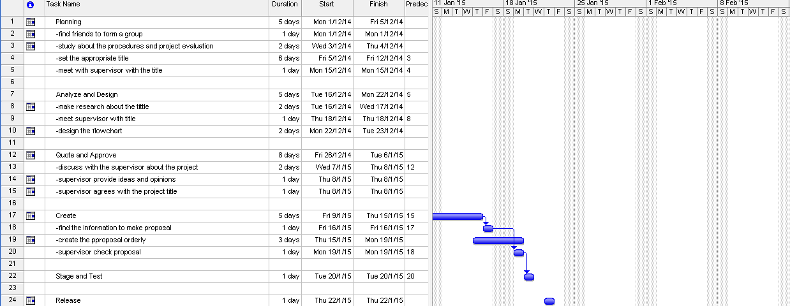)**

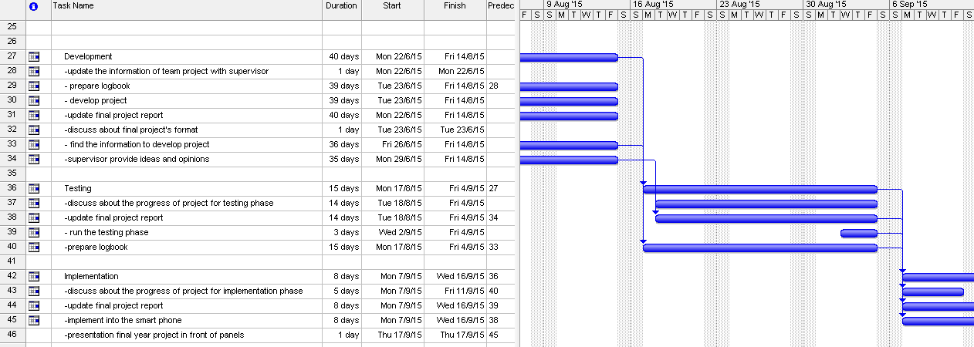**Gantt Chart (Semester5)**

**APPENDIX B**

( INTERVIEW)

|  |  |  |
| --- | --- | --- |
| Date: | 18 February 2015 | |
| Time: | 1:15pm | |
| Place: | Perniagaan Kitabena Temerloh, Pahang | |
| Interviewee: | Mr.Abdul Rafik bin Yusof (Owner) | |
| Interviewer: | Nur Asyifa Binti Dollah Omar | |
| Objective: | 1. To convert a manual system to an inventory system. 2. To help manage the inventory system for the company. 3. To facilitate the process of record, update and delete of the data. | |
| Time | Questions | Answer |
| 2 Minutes | Can you tell me anything about the background of the company? | Firstly, the company start to sell out the items on 1990 with my partners which is my brothers but I’m starting to organize on the beginning of the year 2010.This company addressing at Lot 1378 Kampung Gau Baru km13,Jalan Maran, 28000 Temerloh, Pahang, Darul Makmur. This company just consist 10 of the employee here. Then, the company also supplying the steel products and constructing products. Furthermore, the company offer the painting services, wiring and plumbing building. |
| 2 Minutes | What the types of the products you are buying from the another company and how many quantity of that product? | We are just buying the steel products but with a large of quantity. With the large of the quantity we buy, we do not have a systematic record of the purchase to store the data.. |
| 2 Minutes | How the data of the supplier stored? | .The data it just stored in a lot of file. |
| 2 Minutes | Are you interested if we are offer the management system which is use the barcode scanner to rise up the company level? | We are so interested and strongly agree with the system to develop or using the system as a reference of the company products. |
| 2 Minutes | In your opinion, what are advantages of this company with the system? | The common thing as usual can save the time of the employee to store the data and it will be more efficient and systematic in a manner of this company. |
| 2 Minutes | Can I know the disadvantages of the company if there is no system to develop? | If there is no system is used, there will be a lot of usage of the file and there is not enough space to store the files. |
| 2 Minutes | If the system is developed, what are the element desirable by the user to design the system? | We want the button as a user-friendly, simply to understand, accurate colours, not too bright but not too dim. |

**APPENDIX C**

( MANUAL GUIDE )

